|  |  |  |  |  |  |  |  |  |  |  |  |  |  |  |  |  |  |  |  |  |  |  |  |  |  |  |  |  |  |  |  |  |  |  |  |  |  |  |  |  |  |
| --- | --- | --- | --- | --- | --- | --- | --- | --- | --- | --- | --- | --- | --- | --- | --- | --- | --- | --- | --- | --- | --- | --- | --- | --- | --- | --- | --- | --- | --- | --- | --- | --- | --- | --- | --- | --- | --- | --- | --- | --- | --- |
| |  |  | | --- | --- | |  | **Object Oriented Programming** | |  | **(CL1004)** | |  | **LABORATORY MANUAL** | |  | **Fall 2023** | |  | **C:\Users\Aamer\Desktop\nu-new.png**  **LAB 08** | |  | **Class Relation: Association** | |  | **Engr. Arslan Ahmed** |  |  |  |  | | --- | --- | --- | | ________________________________________ | __________ | ___ | | STUDENT NAME | ROLL NO | SEC | |  | | | | ______________________________________ | | | | LAB ENGINEER SIGNATURE & DATE | | | | **MARKS AWARDED: /10** | | | |  | | | | **NATIONAL UNIVERSITY OF COMPUTER AND EMERGING SCIENCES (NUCES), ISLAMABAD** | | | |  | | | |

|  |  |
| --- | --- |
| **LAB 08** | **Class Relation: Association** |

**Lab Objectives:**

1. To learn one of the class relationships i.e. association
2. **Association:**

If two classes in a model need to communicate with each other, there must be a link between them, and that can be represented by an association. Association can be represented by a line between these classes.

https://cdn-images.visual-paradigm.com/guide/uml/what-is-class-diagram/04-simple-association.png

Most of the class relationships are actually associations, and following are few examples of those:

* **Class Doctor and class Patient**

The association between these two classes can be summarized as patient takes appointment from the doctor

* **Class library book and class student**

This relationship can be stated as student borrows the book

* **Class hotel room and guest**

Guest reserves a hotel room

* **Class flight and passenger**

Passenger reserves a seat on a flight

To develop the association relationship, a data member from either of the class is to be shared with the other class. For example

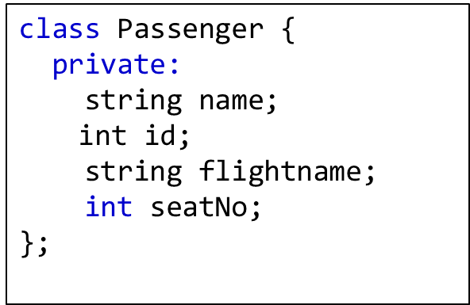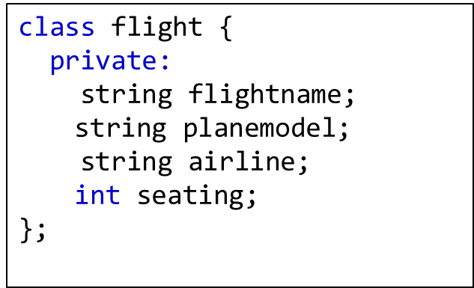

In the above example, which data member is being shared between the two associated classes?

**Lab Tasks:**

Create two classes’ patient and doctor as shown below. Both classes are associated with each other, and share the doc_ID information between them. Create functions in these classes as per the requirement.

|  |
| --- |
| class Doctor  {  private:  int doc_ID;  string docName;  string specialization;  public:  Doctor(int, string, string); //constructor  // other functions  };  class patient  {  private:  string ptName;  int age;  int doc_ID;  public:  patient(string, int, int); //constructor  // other functions  }; |

In the main function, store the information of doctors and patients. For this you need to create arrays of class Doctor and class Patient. For assigning information store data of 8 doctors and 15 patients directly into the arrays in the main program.

After storing the data, perform following Tasks:

**Task01**: Take Input a doctor ID and print patient names for that doctor

**Task02**: Take input a specialization name, and print all patient names dealing with such doctor

**Task03 (Home Task)**: Take input an age, and print all patient names under that age along with the specialization they are dealing with.